REPORT OF THE DEPARTMENT OF FOREIGN PHILOLOGY AND TRANSLATION ON SDG FOR 2022-2023

№ | SDG aims | Topics of events | Date | Report О
1 | SDG 3. Good health and wellbeing | Round table "Prevention of early pregnancy and its harm to the body" within the framework of the UN Sustainable Development Goals program | 13.04.2023  1 course | 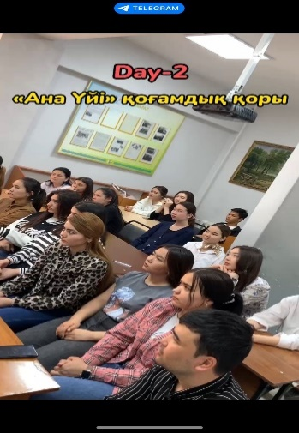
2 | SDG 4. Quality education | What do we know about the history of Kazakhstan? | 06.04.2023  Foreign philology-1 course | 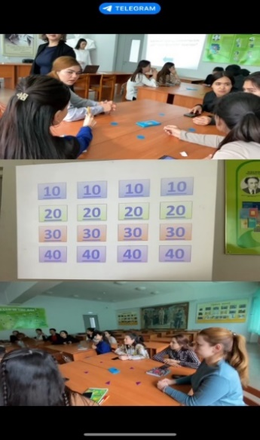
 |  | Master class "A real Kazakh, not a Kazakh without a Kazakh dombra." | 20.04.2023  Foreign philology-1 course | 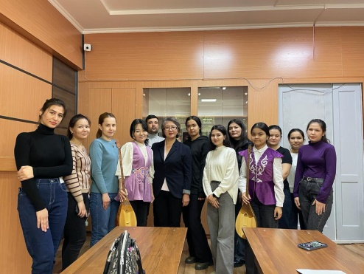
 |  | Visit to the theater with a group | 17.02.23  Foreign philology-1 course | 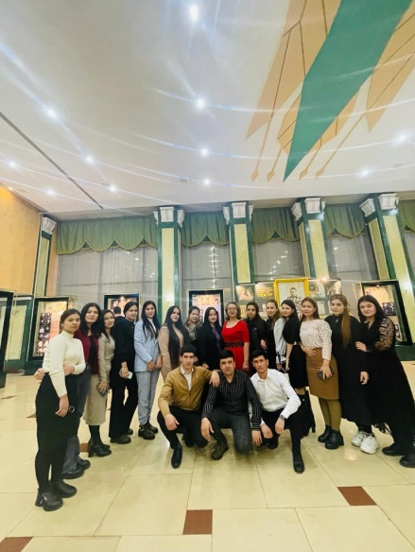
 |  | "Kozy Korpesh - Bayan Sulu" | 04.04.2023, at 1pm  Foreign philology-2 course | 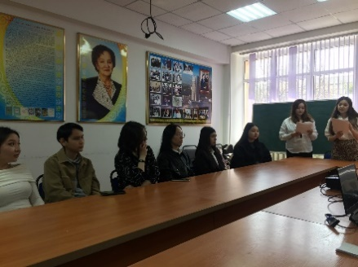
 |  | History of translation of Mukaghali Makataev's works into Russian and English | 28.03.2023, at 2 pm.  1 course – Translation studies  Bachelor's and  Master's programs | 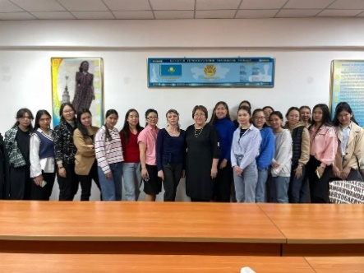
 |  | "Masterpieces of Greek and Roman Literature" | 15.02.2023  1-2 course, Foreign Philology | 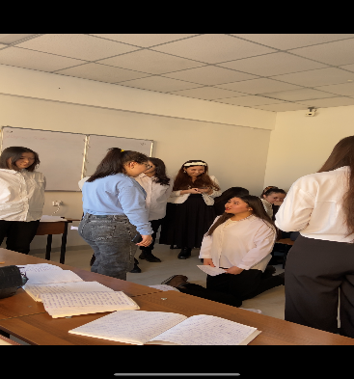
 |  | Academic mobility and writing of motivation letter | 29.03.2023, 12.00, 1 course, Literary studies | 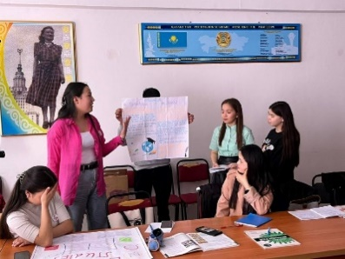
 |  | Education system of the Republic of Kazakhstan and other English speaking countries | 29.03.2023, 13.00, 1 курс, Literary studies | 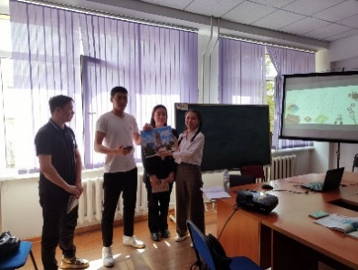
3 | SDG 5. Gender equality | "April 15 Valentine's Day Kozy Kopesh Bayan Sulu" | 04.04.2023  2 course, Foreign philology | 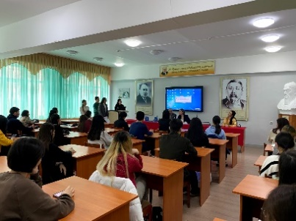
4 | SDG 8. Decent work and economic growth | Synchronist is a translator | 14.03.2023, at 2 pm.  1 course - Translation Studies  Bachelor's degree  Master's Degree  Doctorate | 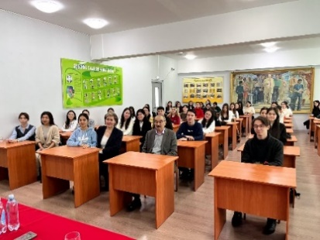
5 | SDG 9. Industrialization, innovation and infrastructure | Educational event: "Translator is a  profession of the future" | The date of the:  25.02.2023  Venue and time: 14:00-14:50  Audience: 312  Course: 2nd year undergraduates in the EP "7M02316-Simultaneous Translation (Western Languages)" and students of "6B02304-Translation Studies (Western Languages) | 